How to use the PanelMinutes.xlsm tool Jack Snoeyink, June 2018

Much, but not all, of the data for panel minutes is captured in reportserver. This tool will query for that data, and let you add some of your own in Excel, then use a Word mail merge template to generate separate P123456_Minutes_date_time.docx files for each panel.

**What you need:** The spreadsheet, PanelMinutes.xlsm, and Word Panel_Minutes_Template.docx should be together in the same folder where you want to generate the minutes. You’ll need a reportserver ID and password, which the spreadsheet can remember for you.

**What to do:** Open the spreadsheet to the Dashboard tab, and fill in

In Table 1, list panel ids, and fill in details on solicitation, program, and pm_ids for secondary PDs (primary comes from PARS).

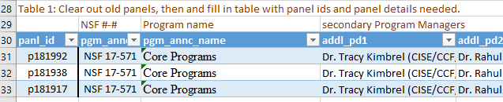

Add any missing PDs to Table 2, and any missing programs to Table 3. The database does not have the abbreviations that we are used to, so we add them here.



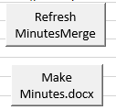Enable Content, hit Refresh, and enter the rptserver password if requested.   
 (Clicking Remember me saves the password.)

Look at the MinutesData tab to see if there are any #N/A#, which indicate that there is PD or program information missing from tables 2 or 3, respectively.

You may want to customize the text in the template for your division/directorate or recommendation scale. When ready, hit Make Minutes to create panel minutes as Word documents named by panel id and date_time, in the same folder as the spreadsheet.

Add information not captured in the database, such as PD conflicts and conflict waivers. Take out any statements (e.g. triage) that do not apply.

**Possible extensions:**  
Check if there are any NDP proposals and omit the triage discussion if not.  
Use the recommendation scale from Fastlane, rather than hardcoding the HC,C,LC,NC.

|  |  |
| --- | --- |
| These are the merge fields currently used in the letter | |
| **org_long_name** | Division |
| **pgm_ele_long_name** | Cluster Name |
| **ProgElemABBRV** | Cluster Abbreviation |
| **pgm_annc_id** | Program Announcement Number |
| **Pgm_annc_name** | Program Announcement Name |
| **panl_id** | Panel ID |
| **panl_name** | Panel Name |
| **panl_bgn_date** | Panel Begin Date |
| **panl_end_date** | Panel End Date |
| **panl_loc** | Panel Location |
| **Nproj** | Number of Projects |
| **Nprop** | Number of Proposals |
| **Nrevr** | Number of Reviewers |
| **Nvirt_revr** | Number of Virtual panelists |
| **officiating** | Officiating PD |
| **signed** | PDs signature |
| **short_name** | PD's short name |
| **today** | The date of the query |
| **Conflicts** | List of conflicted panelists/proposals |